**CS154 Lab01 Report**

1. **Program Commentary & Assembly Code:**

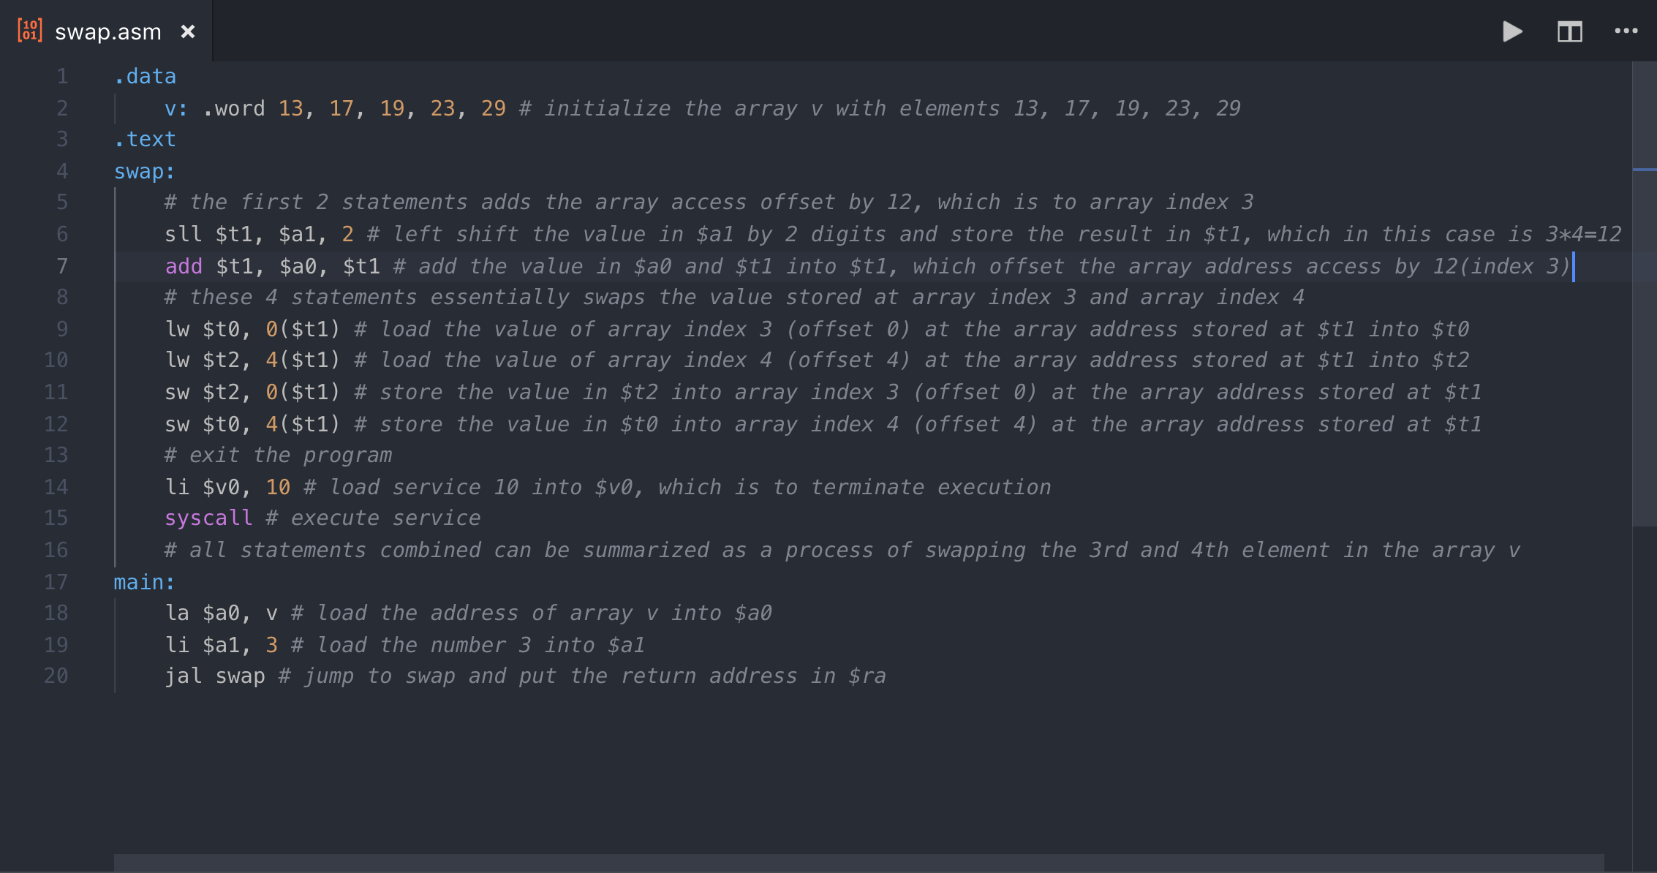

**SPIM Screenshot (Before):**

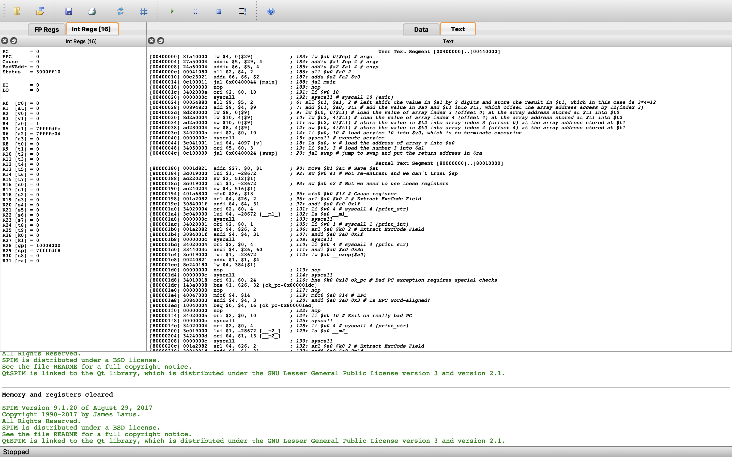

**SPIM Screenshot (After):**

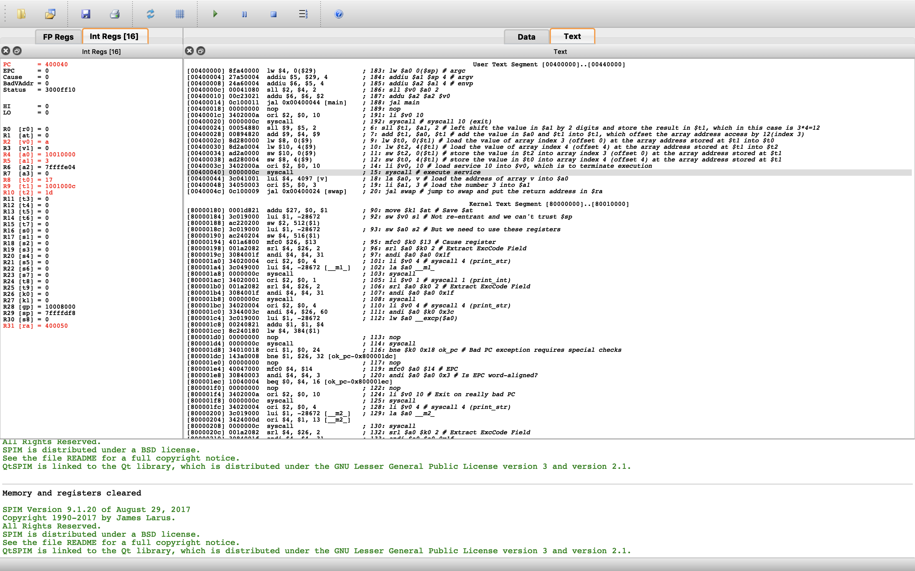

By comparing the screenshot before and after executing the program, the registers highlighted in red changed values throughout the execution. The register v0 contains the value ‘a’ at the end as a is the hex for decimal 10, which is the service code for exiting the program. The registers a0 and a1 contain the address of the array and the array index, respectively. They were used as arguments of the swap function, so they were only initialized and never changed afterwards. The register t0 contains the value stored at array index 3 and the register t2 contains the value stored at array index 4. They were initialized in temporary registers by the load word command and later swapped in the array using the store word command. The swap used the address after the offset which is stored in register t1. The register t1 contains the array address after the offset provided by the argument a1. Since a1 is 3, an offset of 12 was added to the array address 10010000 stored in a0 which resulted in 1001000c and stored in t1. Finally, the ra register also changed due to the jal command as it stores the return address. This register, however, was not used in this program since the swap function doesn’t return to the main program but rather exit the program right away.

1. **Sort Function Complete MIPS Assembly Code**

